МКОУ «Ахкентская СОШ»
Учитель английского языка Абдулзагирова Айшат Абдулзагировна.

Конспект урока по английскому языку для 9 класса по теме «Для чего мы учимся?».
Тема урока: "Для чего мы учимся?" (What do we study for?)
Цели урока:
- активизация лексических единиц и речевых клише в устной речи по заданной теме;
- повторение способов словообразования;
- совершенствование речевого запаса умений вести дискуссию, отстаивая свою точку зрения.
Технологии: активизация возможностей личности и коллектива; "BrainStorming" (Мозговой штурм).
Оборудование урока: компьютер, проектор, аудиофайл, экран, компьютерная презентация,
Дидактический материал: схемы-алгоритмы для обучения аргументированному высказыванию
Лексический материал: клише для выражения личного мнения.
Грамматический материал: основные коммуникативные типы предложений

Ход урока
1. Начало урока (5 мин.)
Цель, которую ставит учитель: создание благоприятной психологической атмосферы урока и подготовка учащихся к продуктивной работе, заинтересованности к предлагаемому материалу.
Цель, которая должна быть достигнута учащимися: готовность класса к продуктивной деятельности.
Задачи: введение в тему урока, стимулирование мыслительной деятельности, развитие фонетических навыков, развитие памяти и кругозора.
Teacher: Hello, boys and girls! I am glad to see you. How are you? I’m sure that you are full of energy and ready to do our lesson interesting and exciting. We’ll be speaking about school life. The theme of our lesson is: "How do we get knowledge?".
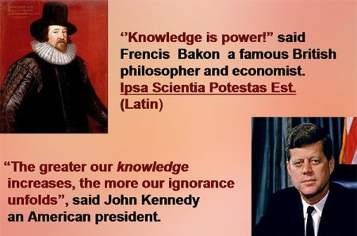
I want to enlarge your erudition with the acquaintance to the following quotation. Please, look at the first slide, try to pronounce and learn by heart these sayings of the outstanding people.
2. Цель, которую планирует достичь учитель: расширение и закрепление базовой тематической лексики, развитие способности её актуализировать.
Цель, которая должна быть достигнута учащимися: умение дать незамедлительный перевод и актуализировать лексику в кратком личном высказывании.
Let’s train the list of words on the topic "Education" to keep them in your memory and operate with them easily when it’s required. They will be of great use to you if you want to speak fluently on the topic about school, learning and education. Translate the following words and use them in your sentences. (5 мин.)
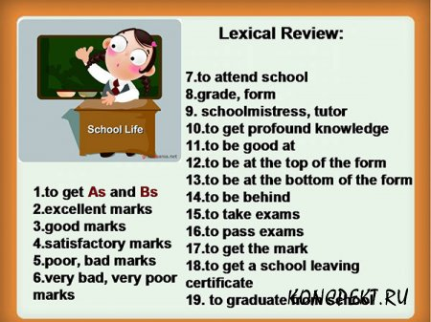
3. Цель, которую планирует достичь учитель: формирование моделей словообразования в сознании учащихся
Цель, которая должна быть достигнута учащимися: незамедлительно строить слова по предложенным моделям
The next kind of work I’d suggest you is word building, try to recollect the laws of formation different word classes. The perfect knowledge of these rules will be very useful to you in the process of learning a foreign language. (6 мин.)
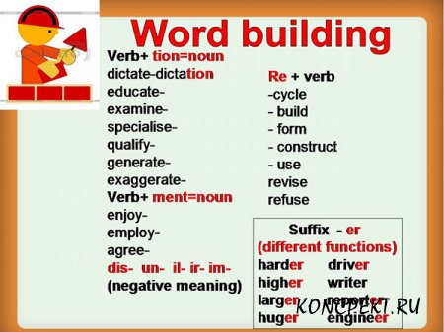
4. Цель, которую планирует достичь учитель: развитие умения высказывать свою точку зрения, используя имеющийся словарный запас, незамедлительная формулировка аргументированного ответа.
Цель, которая должна быть достигнута учащимися: умение высказываться по теме, умение слушать и понимать заданный вопрос, логика и связность развернутого ответа.
Let’s continue our lesson with the answers to some questions which will make you think on the school matters and define your personal position. (6 мин.)
- Do you enjoy going to school? If so, why or why not?
- What makes a "good student"?
- What skills separate good students from bad students?
- What makes a "good teacher"?
- Do you think a person can become a genius, or are they just born that way?
- Why do some children have trouble doing schoolwork? How can we help them?
- What should or shouldn’t students do to achieve high academic results?
- In your opinion, what is the most important aspect of education?
5. Цель, которую планирует достичь учитель: совершенствование навыков диалогической речи через беседу по теме, развитие умения высказывать свою точку зрения, аргументировать своё мнением, соблюдая нормы этикета.
Цель, которая должна быть достигнута учащимися: умение самостоятельно высказываться по теме, аргументируя свою точку зрения.
Now it’s time to make up some dialogues to show you ability express your ideas, give your arguments, agree or disagree. Please, with your partner discuss the given topics. (7 мин.)
Учащиеся обдумывают ситуацию 30-40 секунд, реагируют на реплики партнера, инсценируя неподготовленный диалог, инициатором которого может выступить любой из партнеров.
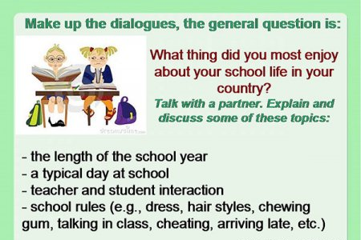
Ученикам предлагаются карточки со вспомогательной визуальной опорой.
The list of useful phrases
To tell the truth  It goes without saying  Therefore  Nevertheless  Moreover  So to speak  Indeed | Fortunately  Unfortunately  In any case  Anyway  In other words  As far as I know  Frankly speaking
6. Цель, которую планирует достичь учитель: совершенствование навыков монологической речи по теме, развитие умений речемыслительной деятельности, соблюдая последовательность и логичность высказывания на основе лексически структурированного материала.
Цель, которая должна быть достигнута учащимися: умение спонтанно, но грамотно выстраивать инициативное монологическое высказывание.
Now it’s time to try and compose your personal story in the form of the monologue about the school you study at, because you have learned enough material and studied a group of words to support you. The first pupil will begin the text and the other classmates will continue your general story, it should be logical, fluent and logical. (7 мин.)
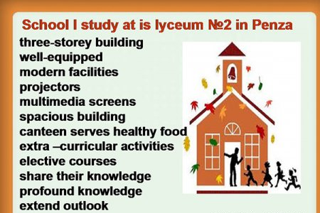
The approximate pattern of the answer
At the present moment I’m a student of the Lyceum of Modern Technologies № 2 in Penza. It’s situated rather not far from my home, as a rule I get there on foot and don’t take any transport. It’s a three storey building in Bakunin Street. Many prominent people of our city graduated from it and I believe some of my classmates follow their steps.
The lyceum is well-equipped, it has a lot of spacious classrooms with modern facilities: computers, projectors, multimedia screens, spacious halls and a good canteen which serves healthy food. We have a lot of extra - curricular activities and elective courses, which students choose, for the purpose of their personal development.
Our teachers share their knowledge with us, extent our word outlook and help us find our way in life. We get profound knowledge there and develop our abilities. I believe our school is the place where we mold oneself as personalities and find devoted friends. For me my school is the place where I want to come every day where I meet people who love and understand me.
7. Цель, которую планирует достичь учитель: совершенствование навыков восприятия на слух, научить извлекать фактическую информацию.
Цель, которая должна быть достигнута учащимися: готовность воспринимать текст на слух с целью уметь извлекать фактическую информацию.
It will be very useful for you to listen to the topical texts and fulfill the task, in your personal supplementary cards you see two tables, give the right answers on the following points. You will listen to texts A-E, put each speaker into the proper column. Point two, then I’d like you to complete the next table, which will indicate your ability to match some details from the text you listen to the proper speaker. (8 мин.)
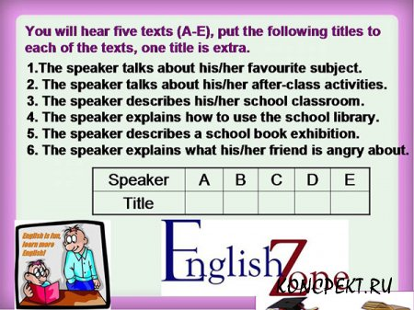
Table № 2
A | B | C | D | E
- The speaker mentions about low grades in Maths, but it doesn’t make him unhappy. (C)
- The speaker says that good performance depends a lot on their ability to research and look for information. (E)
- The speaker describes their classroom in detail. (A)
- The speaker spends many hours at studies with pleasure. (B)
- The speaker says that he enjoys sport greatly. (D)

Script
Speaker A
It’s large and spacious. There is a whiteboard, desks and a teacher’s table but the most interesting feature is the special graffiti wall. We can write all kinds of questions on the material we are studying at the moment. For example, if you don’t understand something, you can write your question on the wall and another student or teacher writes the answer.
Speaker B
I’m always glad to come to this room some time before the lesson and study the maps on the walls and samples of stones and rocks on the shelves. Yes, I find geography very interesting and it’s not a problem for me to spend hours writing out facts about famous travellers and their discoveries. My favourite classroom activity is studying and completing maps.
Speaker C
My grade for the Maths test was unusually high but I’m not happy about it at all. My friend Tracy isn’t talking to me because of this. The thing is that in the exam room I sat next to Tracy and she’s sure I copied the answers from her paper. That’s not true but she doesn’t believe me. She thinks I cheated and she hates any dishonesty.
Speaker D
I study in a large and modern school with well equipped classrooms, a good gym and a swimming pool. The latter are very important for me because I use them practically every day. When the lessons are over, my friend and I go to the gym to exercise or to play volleyball. Twice a week I have a swimming class and my friend does all kinds of experiments in the school chemistry laboratory.
Speaker E
Students’ performance depends a lot on their ability to research and look for information by themselves. On the shelves the books are arranged in the alphabetical order. To find the book you need to know the author. There is also an electronic catalogue and access to the internet resources. Just type in the key word to find whatever you want.
Answers: 31624
8. Рефлексия (1 мин.)
I guess our conversation during the lesson put you on the new level of speaking English. You got the new ability to express your thoughts and ideas about school and studies. Thank you very much for active participation in our common work. I think everyone showed the utmost of ones abilities. I believe the suggested pieces of work helped you to improve your English. I appreciate you work and put the following marks…
9. Домашнее задание (1 мин.)
Цель, которую планирует достичь учитель: развитие умений, приобретенных на уроке, и умение аргументировать свое мнение.
Цель, которая должна быть достигнута учащимися: закрепление умений приобретенных на уроке.
Activity book: lesson № 1, написать высказывание о родной школе (12-15 предложений).

